Load Testing with JMeter assignment document

Screenshots:

User: 167, Time: 60s

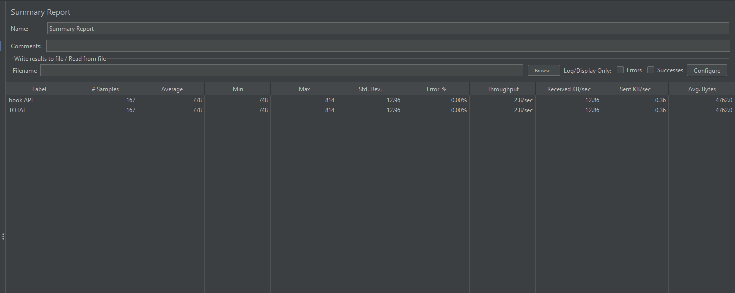

User: 833, Time: 300s

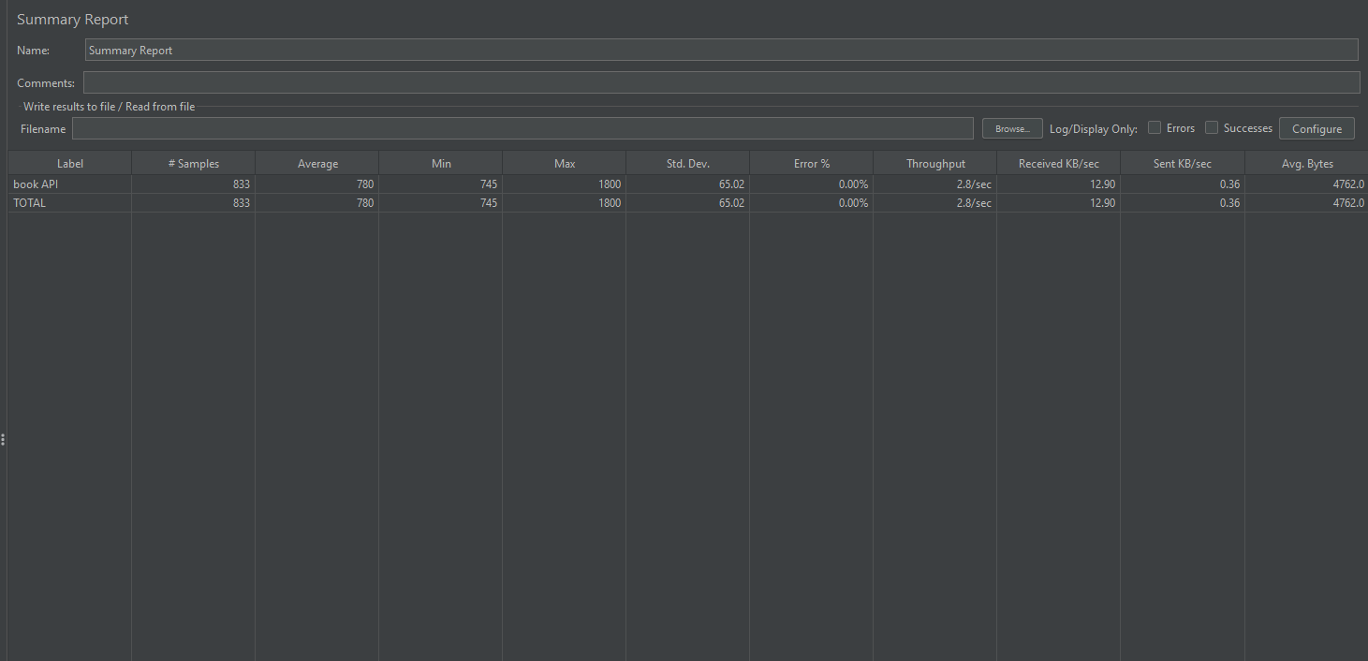

User: 1667, Time: 600s

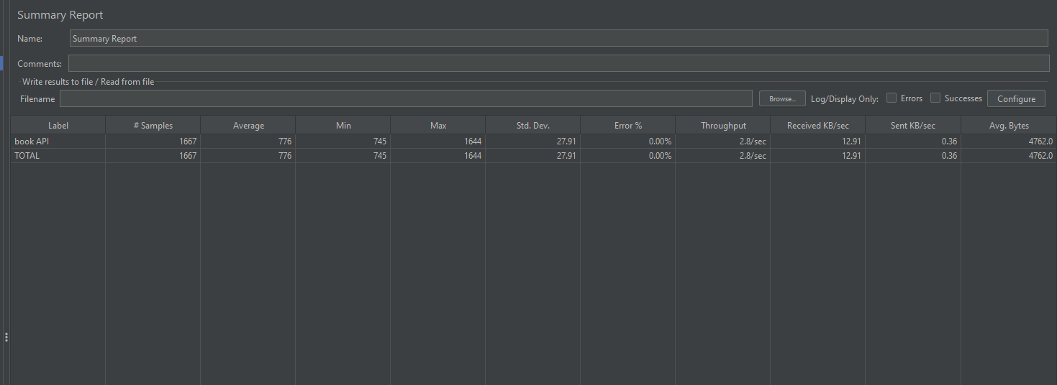

User: 2500, Time: 900s

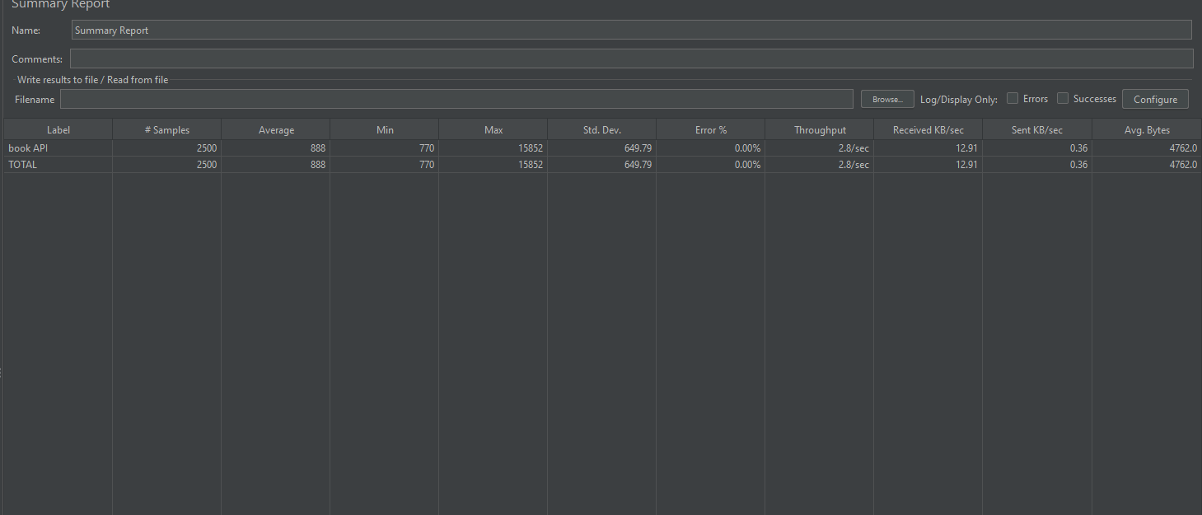

Command line interface while testing from backend:

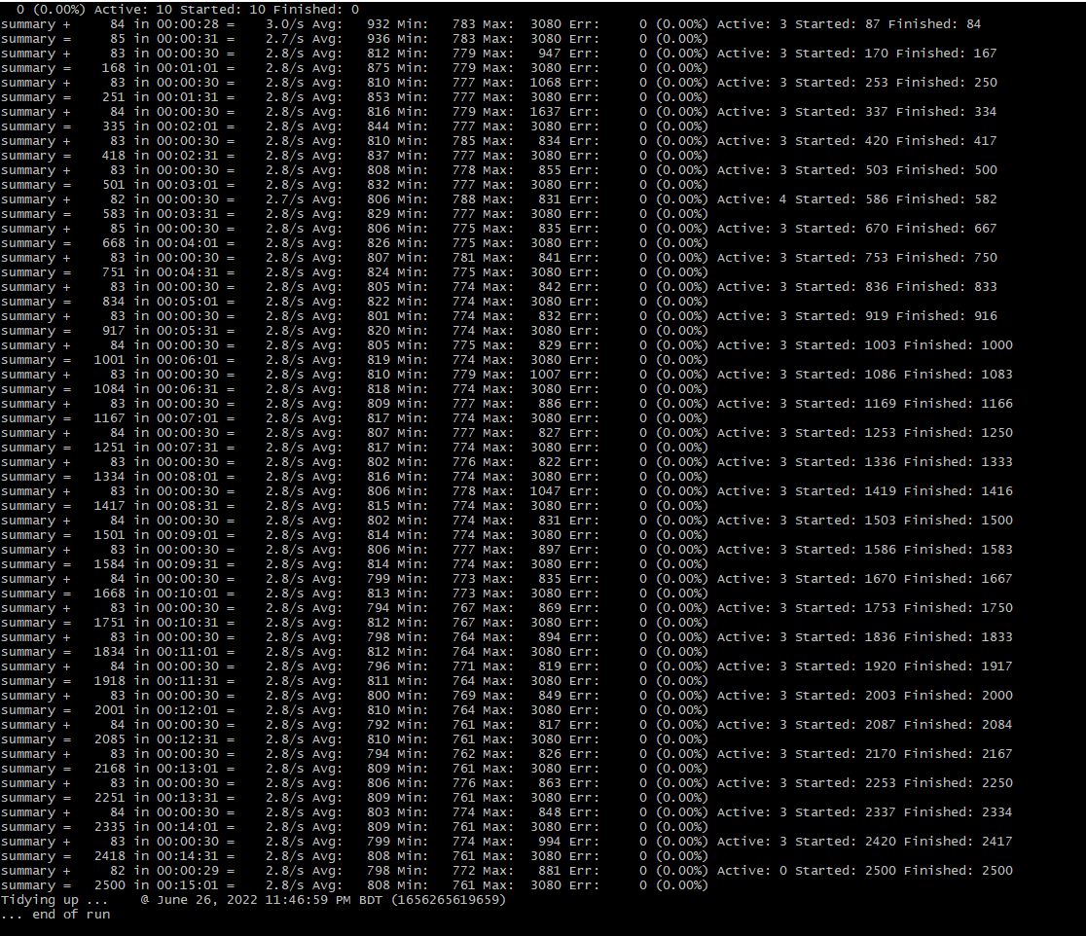

Html Report on browser:

